Ayub Khan’s Basic Democracies
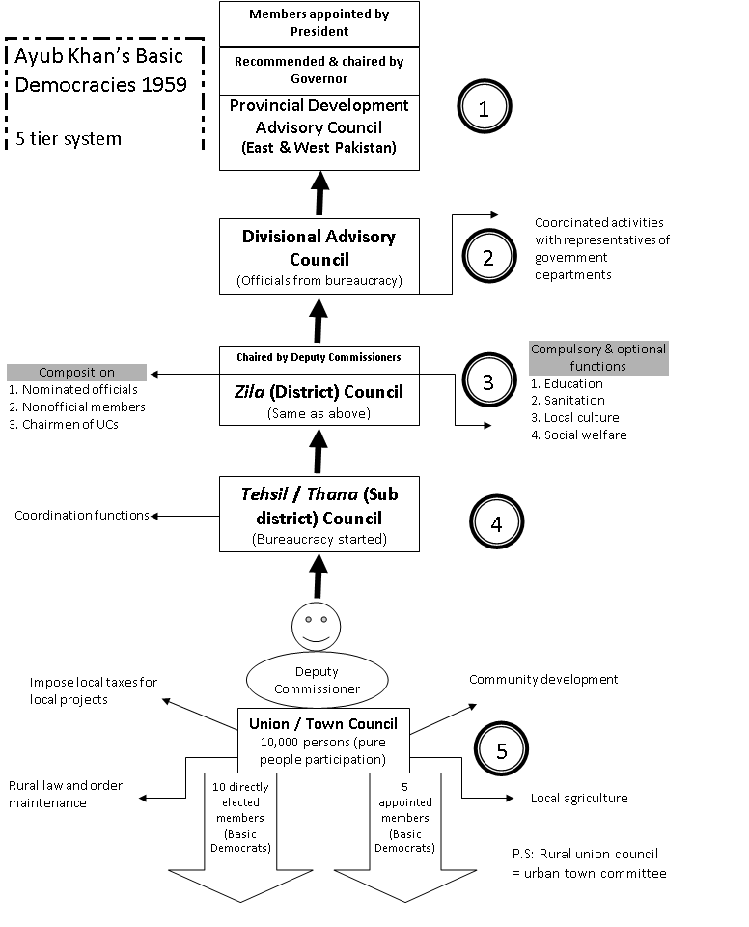

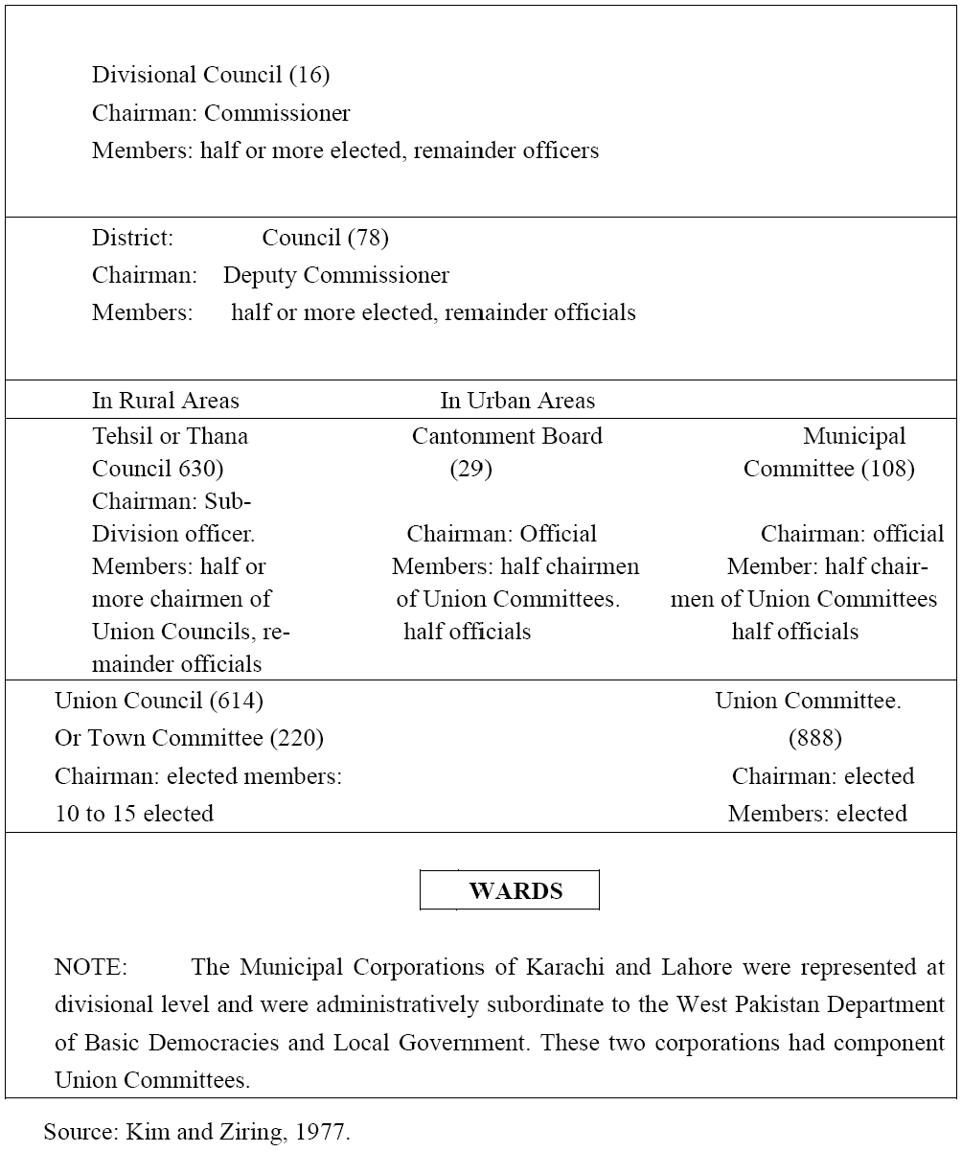
These were replaced in 1962, reduced to four-tier hierarchical structure of union council / union committee, tehsil council / town committee, district council and divisional council.
Basic Democracy Structure, 1965
Salient features of the system are presented below.

- a) Indirect democracy

- b) Broad mass of people would elect an electoral college

- c) 80,000 Basic Democrats or Union Councillors

- d) Non-party basis elections

- e) These local leaders would elect the legislature and the President

- f) Constitution of 1962 linked the office of the President to the local bodies.

- g) System of guided democracy comprised elected and non-elected representatives with a local administration acting as the eyes, ear and stick for the central government enabling it to maintain sufficient authority over the politicians (Siddiqa, 2007).

- h) Under the system each province would have to elect 40,000 Basic Democrats each representing at that time, about one thousand populations, out the total of 80,000 was eventually raised to 120,000.

- i) These councils were to have developments responsibilities so that the overall political plans would be built upon the views and needs of the local areas (Islam, 1990). Law and order duties eventually encompassed some powers under the Family Law Ordinance and some ability to tax. Despite the splendid administration about decentralization of power, the bureaucratic control over Basic Democracies System remained firmly in place.

- j) Because the civil servants were responsible for selecting candidates there by extending detailed administrative control over political issues (Noman, 1988).

- k) Initially Deputy Commissioners were appointed Chairman of higher tier of local bodies. Their continued dominance of the Tehsil/Thana; the District and the Division left their influence unimpaired (Kim & Ziring, 1977).

Critical Analysis

Following points give the summary of the critical study of the system.

- a) This system ruled out the political activity. This is the key to the in-depth analysis of the system. The presentation of the people was not in the political arena rather they were involved in the economic development. This was not the case that they were given the political independence or training.

- b) This system offered avoidance in the decentralization of powers as far as the political power is concerned. Only the developmental authority was decentralized to some extent.

- c) This system in its core was based on the political system without any politicians.

- d) This system negated the so far achieved progress in the area of democratic culture or political participation in the country.

- e) This system provided stability and security to the President but did not strengthen the political system itself.

- f) Institutionalization of the political system did not happen.

- g) Political culture was not developed.

- h) Restrictions and bans on freedom of expression and media etc made sure that the democracy could not prevail in the country.

- i) Controlled structure of local government offered no good to the people of Pakistan.

- j) It was portrayed that bureaucracy and colonial practices were to be abolished but in fact it was more strengthened.

- k) Basic Democracies showed more capability and capacity in economic field rather than the political field.

- l) It showed the pattern of western political concept.

- m) Ayub Khan‟s concept of democracy found expression in the shape of Basic Democracies which infect was more basic than democratic. It may be said that it made easy to bribe and buy the voters.

- n) Due to the system a disparity between the East and West Pakistan emerged that East Pakistan had more population than the West Pakistan but the equal representation in the Basic Democracies system increased the sense of disappointment among the people of the Eastern wing. According to Craig Baxter (1988) “East Pakistan was of course under represented as it had been under the parity arrangement”.

- o) This „guided‟ and controlled democracy allowed the bureaucracy to override council proceedings, overrule their resolutions and decisions and even suspend elected members of the councils.

- p) The government used the bureaucratic control from the center to limit political competition at the local level.

- q) In February, 1960 elected representatives assumed their responsibilities. In February 1960, Basic Democrats were asked to say yes or no on a simple question; “have you confidence in President Ayub Khan?” General Ayub Khan was elected President by a 95.6 % of yes votes, an exercise which made East European elections look glamorous (Noman, 1988).

- r) Politicians criticized that the use of elected officials as an electoral college denied the population of their right to directly elect the President. In this way elections could be bribed, bought and paid for and their rules easily compromised.

- s) Under the system of Basic Democracies the President established autocratic rule in Pakistan with the help of bureaucracy.

- t) Provincial autonomy was circumscribed further through the appointment of governors, answerable to the center.

- u) General Ayub Khan‟s intent was not to decentralize or devolved authority to grass roots level but to extend centralized control over the federal units through a grass root political base.

Conclusively speaking, the Basic Democracies system was remarkably well orchestrated for extending direct patronage to, and manipulation of local power structure.

Journal of Public Administration and Governance ISSN 2161-7104 2012, Vol. 2, No. 1

